# Advanced Gwent: Math and Calculators

**Proposition**: we can use any of three tools to craft the best decks:

1. Hypergeometric calculator - ***% of having card in opening hand.*** [Link](http://stattrek.com/online-calculator/hypergeometric.aspx#faq)
2. Overlap calculator - **% of drawing cards together.** [Link](https://jscalc.io/calc/XXJbvsNuHPUbtG8A)
3. Pen and paper

Let’s talk about them.

## Hypergeometric calculator

Very initiative tool and it’s very much useful in every card game including Gwent. One of the primary things you wanna calculate in any time you are building a deck is ***what’s your probability (%) of having card in opening hand***.

Here is the [Link](http://stattrek.com/online-calculator/hypergeometric.aspx#faq) to the online calculator.

Tips:

1. Population size - # of cards in deck (usually it is 25)
2. Number of successes in population - # of target cards (these are the cards that fit your criteria):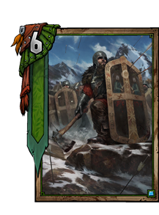

*Ex. 1*: it you’re trying to calculate the probability of drawing Mahakam Defender in the your opening hand, you would have a number of successes in population of **3**.

*Ex. 2*: it you’re trying to calculate the probability of drawing muster units, you would be able to the number of musters you’re running. For instance, you’re running both Foglets and Crones, you have a number of successes of **6** in the population. Of course, this only accounts for the probability of drawing multiple musters. It doesn’t provide you with the probability of drawing multiple copies of each of them (look at Overlap calculator).

1. Sample size - # of draws (that is the amount of cards at your disposal)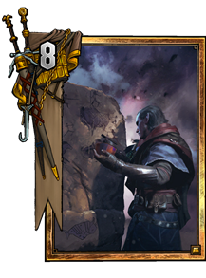

*Ex. 1*: you’re running 25 card deck, you’re trying to calculate the probability of drawing any given card, then you have a sample size of **10**. That’s the amount cards you draw from the top of the deck when the game starts.

*Ex. 2*. If you’re trying to calculate to calculate the probability of drawing any given card when you use Avallach (e.g.), you have a small population size (e.g. **15**) since you have less cards in your deck and a sample size of **2**, the amount cards you draw.

1. Number of successes in sample (x) - # of target cards in sample size (the amount of cards you’re testing for)

*Ex. 1.* If you want the probability of drawing at least a Mahakam defender in your opening hand, knowing you run 3 of them, and your opening hand has 10 cards, you insert **1** as the number of successes in the sample size. And the calculator gives you the value for precisely one Mahakam Defender as well as the probability of drawing more than one.

## Overlap calculator

This is very similar to the first one except for gives you the probability for having combo pieces in a hand in any given time (**% of drawing cards together**). For instances, Dol Blathanna Protector and Farseer.

You know you need to have one least protector in your hand to enable your Farseers. Using the Overlap calculator ([Link](https://jscalc.io/calc/XXJbvsNuHPUbtG8A)), you can calculate exactly what the probability of this is.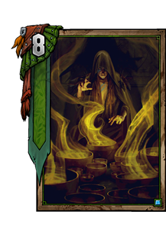

After you insert the Deck Size and Hand Size, simply trip group A as Farseer. There are 3 in your deck, so you input **3**. And Group C (Overlap) as Protector, again 3 in your deck. So the number we input is **3**. Leave group B empty and voila:

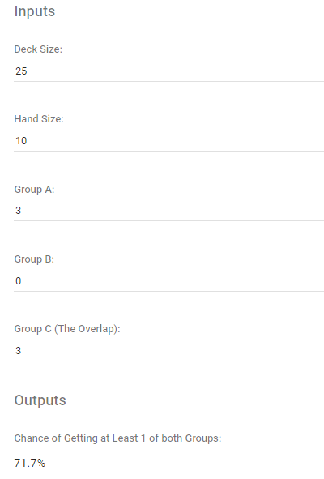

You gonna 71.7 percent chance you gonna least 1 of each in your opening hand, not counting mulligan.

You can also use the overlap calculator for negative purposes: if you don’t wanna draw both wild hunt hounds and a biting frost, you simply calculate the probability of drawing one of each and then subtract that number from (a hundred)? ticket the probability of not drawing both of them.

## Pen and paper

### Pre-deckbuilding (Inventories)

Just simply go to the deckbuilder of your chosen faction and make an **inventory** of the amount points cards any given cards can get.

Ex.1: Monster faction:

* Nekker: 3 points + 1 point per consume
* Caranthir: 8 points + 2 per turn (Frost) / One movement
* ....

**Don't give values to things you can't value reliably!!!**

### Deckbuilding itself (iterative process)

#### Solve the puzzle

After you created the **inventory** you **should solve the puzzle** which consists of two stages of deckbuilding:

1. Identify your win conditions. In Gwent you need to win 2 rounds from 3:
   1. “How do I win round 1?”
   2. “How do I win another round?”
2. Maximize value:
   1. Look at your inventory
   2. Choose a cards that benefit your strategy and bring the maximum number of points

#### Look at your deck

* Remove contradictions [противоречия]. *Ex*: Remove Scorch from Ciri: Nova deck.
* Check if you didn’t forget anything\
* Apply the calculators
* Look outwards [наружу] - look at the meta, look at the popular decks. *Ex*: if there is a weather meta, then you should add silver mage or weather clear to your deck.

#### Adjust

* Consider control. *Ex*: cards like Mardroeme, Lacerate… don’t exist in vacuum, they depend on the meta.
* Play games: test your decks
* Minimize variance: make sure you falling up on the theory and using all mathematical tools at your disposal to minimize variance.

All of the above is a puzzle, so you need to solve it correctly.